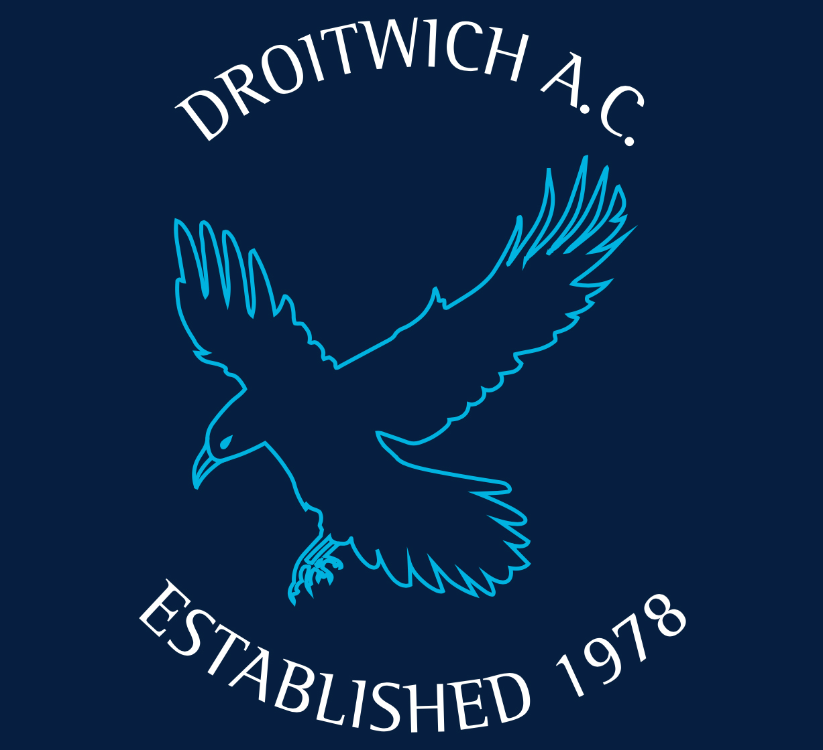
Droitwich Athletic Club
Adult & Junior
Membership application form

Title |  | Forename
Surname |  |  |  |  |  | Gender
Email
Home phone
Mobile(s)
Junior/Adult |  |  |  | Single/joint
Date of birth
House number |  |  |  | Road
Town |  |  |  |  | Post code
Nationality
If junior – school attended
Are you affiliated to another athletics club? – if so…..
Name of club: |  |  |  | UKA number:
Please state any medical conditions, allergies or disabilities that the club should be aware of:
Any medication that will be brought to the club:
May your photo be used in DAC publicity? |  |  |  |  |  |  |  | Yes/no
Do you consent to being contacted by DAC for general purposes; information; dates etc? |  |  |  |  |  |  |  | Yes/no
NB: In an emergency, we will make every effort to contact you or your family by any means possible.
If you are completing this for a junior member please only add parental emails and phone numbers.
All of this data is treated confidentially. Most if it goes to England Athletics where you will be able to access it. None of it will be passed on to any other third parties at all. It will be stored in password secured areas and the paper copy will be locked into the athletics club container by the athletics track. Any records/data more than five years old will be destroyed.
“When you become a member of or renew your membership with Droitwich AC you will automatically be registered as a member of England Athletics. We will provide England Athletics with your personal data which they will use to enable access to an online portal for you (called myAthletics). England Athletics will contact you to invite you to sign into and update your MyAthletics portal (which, amongst other things, allows you to set and amend your privacy settings). If you have any questions about the continuing privacy of your personal data when it is shared with England Athletics, please contact dataprotection@englandathletics.org.”

I declare that I am an amateur, qualified to compete under the rules of the UK Athletics (UKA).

Signed: New member: __________________________________________________________________________ Date: ________________________

For parents of juniors: I agree to my child being taken to hospital or to be seen by the nearest doctor should an emergency arise.
Signed by parents of a new junior member: __________________________________________________ Date: ________________________

Name of contact parent for junior member: __________________________________________________________________________________

Please return this form together with the appropriate remittance (cheques payable to Droitwich AC – amounts are published on the Droitwich AC website) to – DAC membership, Peter Rean, 61 Corbett Avenue, Droitwich, WR9 7BH. Contact email: chairman@droitwichac.co.uk

For more details about DAC visit our website and sign up to the run groups and junior athletics Facebook pages.

If you have further details of medical needs or issues, please outline these on the reverse of this form. Run leaders and coaches will need to be informed of these, before training sessions, if necessary.

